**ENQUIRES**:

**Liane Walters - 0413 021 916 -** [**geordina2002@yahoo.com**](mailto:geordina2002@yahoo.com)



## Saturday 7th September 2019

## Horse Section PROGRAM

**All rings commence at 8:30 am**

**and conclude no later than 4:30pm**

**Lunch break 12:30 – 1:15 pm**



**SUPREME LED OPEN EXHIBIT**

**SUPREME RIDDEN OPEN EXHIBIT**

**SUPREME RIDER**

**SUPREME LED SHOW HUNTER**

**SUPREME RIDDEN SHOW HUNTER**

**SUPREME LED BREED EXHIBIT**

**SUPREME RIDDEN BREED EXHIBIT**

**Grand Champion Clydesdale of the Show - Les Williams Memorial Trophy**

**junior feature hack of the show**

**open feature hack of the show**

**Prize money**

**Champion $10.00**

**Reserve Champion $5.00**

**(unless otherwise specified)**

**Ribbons to 3rd place   
(unless otherwise specified)**

**(TO BE JUDGED AT THE CONCLUSION OF ALL CLASSES IN RING 3)**

The Juice Brothers 2018 Leeton Show Page 1

**Broad Sashes and Rosettes for All Supreme Winners**

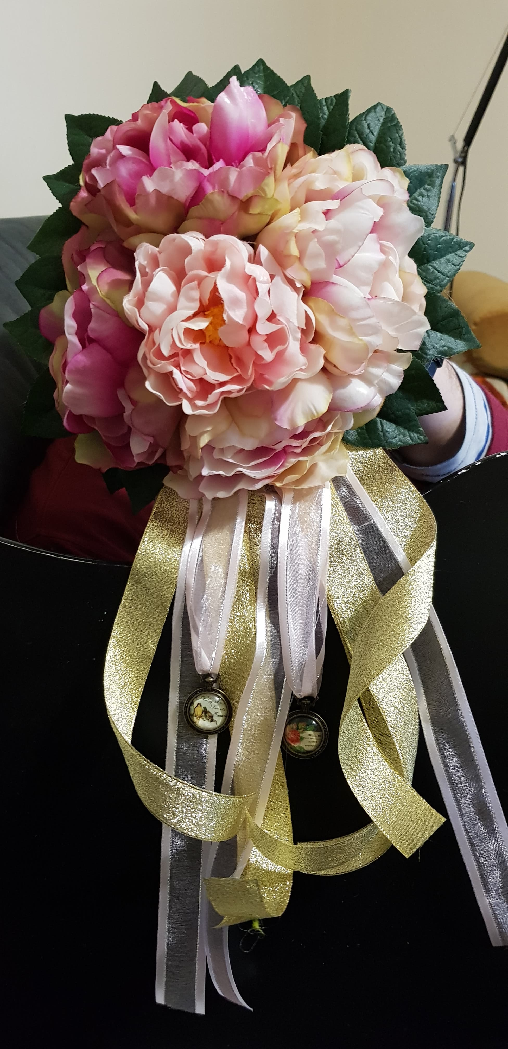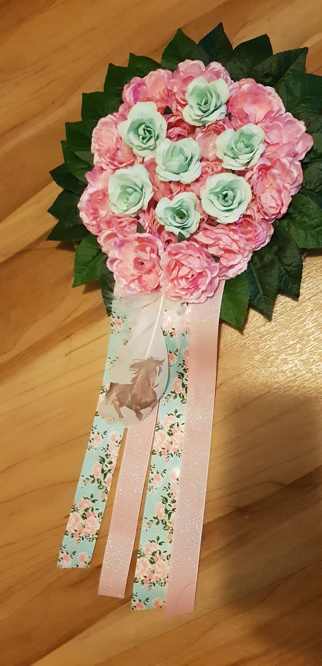

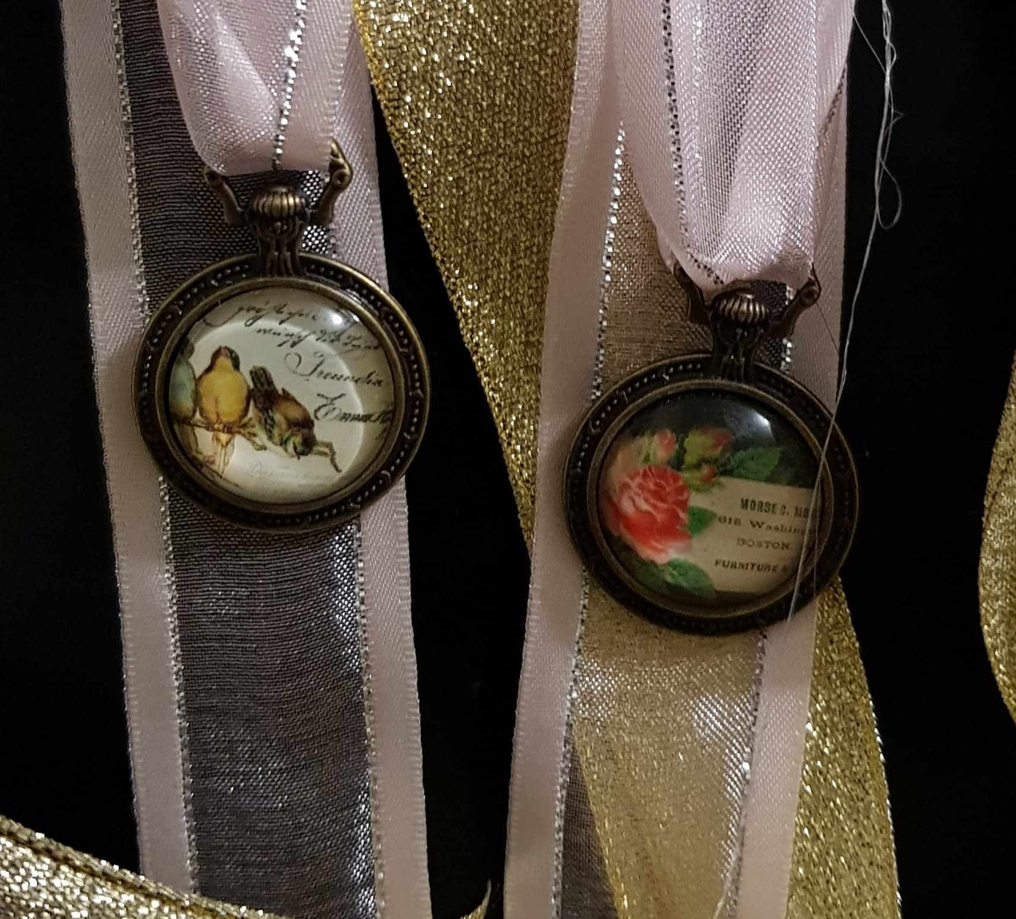

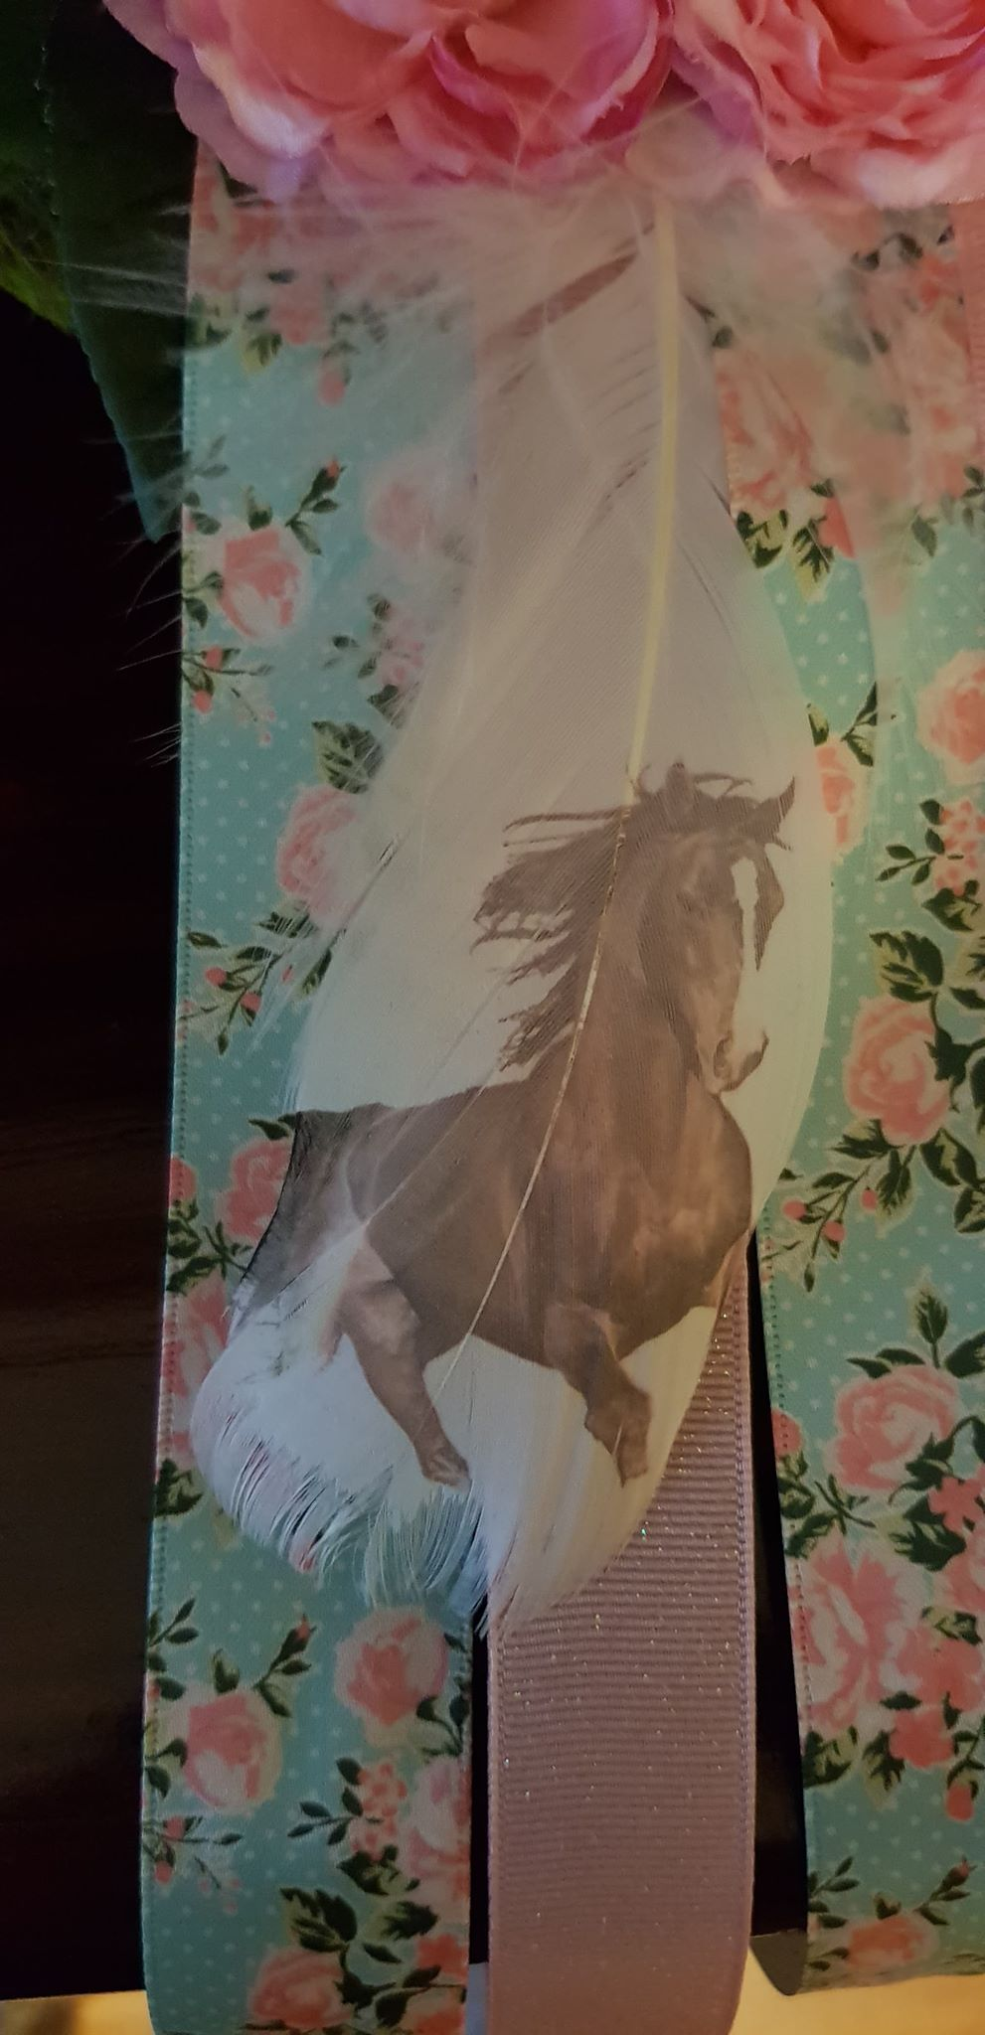

**John Walker and JB Showhorses**

**Sponsor of supreme rider**

**V Sashes for Junior Feature Hack of the Show and Senior Feature Hack of the Show**

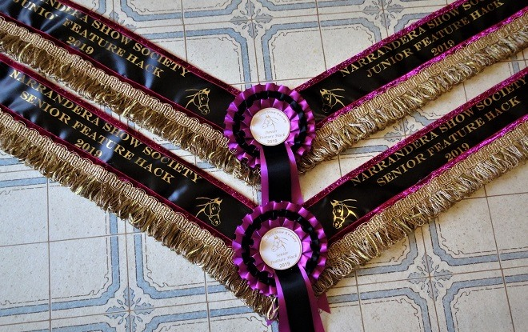

**Senior Feature Hack of the Show also receives a Saddle Stand from Horsepower Innovations** **and a gift voucher from the Australian Equine Institute to complete a subject towards the Certificate in the Certificate in Horsemanship - prize value of $500**

**Junior Feature Hack of the Show also receives gift vouchers from Show Selections Browbands , Hamag Equestrian Supplies, The Complete Equine Diary and a gift voucher from the Australian Equine Institute to complete a subject towards the Certificate in the Crtificate in Horsemanship - prize value of $500**

**TO BE JUDGED AT 11:30AM BY ALL JUDGES IN RING 5 – $10 PER ENTRANT**



**OUR WONDERFUL SPONSORS**



**Standardbred Classes**

**Proudly sponsored by**

**The Standardbred Pleasure & Performance Horse Association of NSW Inc.**



**Show Hunter Ring  
Proudly sponsored by the Australian Hunter Horse Association**

**Led and Ridden Classes for AHHA members**

**Join on Nominate:** [**https://nominate.com.au/EquiBase/MemberSignUp1.aspx?sid=32&eid=14&fbclid=IwAR0TJQkBAPLcj6OzSpPv0RYWICQfMXot9XPPp6v0nzY9-pLu0l0lyrs-cTo**](https://nominate.com.au/EquiBase/MemberSignUp1.aspx?sid=32&eid=14&fbclid=IwAR0TJQkBAPLcj6OzSpPv0RYWICQfMXot9XPPp6v0nzY9-pLu0l0lyrs-cTo)

**All competitors go into a draw to win a prize from one of our sponsors. Winners drawn and announced at lunchtime. Prizes to be collected on the day.**





**Shezam Equestrian**



**SHOW SELECTIONS BROWBANDS**

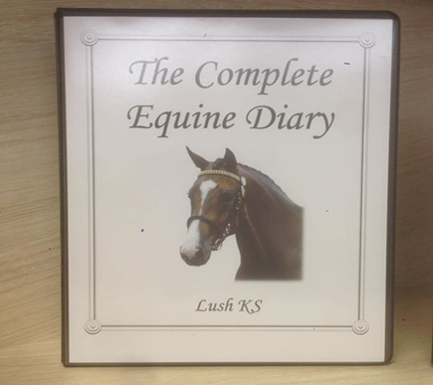







**ENTRY COSTS**

**Gate Entry - $20 (will be collected on Saturday morning)**

**Tickets for classes $2:00 each (enter on the day)**

**Discount for bulk purchases**

* **5 tickets for $8**
* **10 tickets for $16**
* **20 tickets for $34**

**Junior Feature Hack & Senior Feature Hack Tickets: $10 each**

**To be purchased on the day at the horse shed and presented to the Steward upon entry into ring.**

**----------------------------------------------------------------------------**

**Camping**

* **Unpowered site - $15 per night**
* **Powered site - $20 per night**

**Stalls - $10 per night**

**To book camping sites and stalls call Pam & Bruce Guymer (02) 6959-2581**

**-----------------------------------------------------------------------------------------**

**HORSE SECTION – Regulations**

*All competition at this show is governed by these regulations and by the Agricultural Societies Council of NSW Rules for Discipline in Horse Sections at Shows which can be viewed at [www.agshowsnsw.org.au.](http://www.agshowsnsw.org.au/) Should it become necessary for the ASC Disciplinary Committee to open an inquiry into any aspect of competition in this Horse Section, this Society will support any penalty imposed by that Committee as a result of the inquiry and will support penalties resulting from enquiries arising from Horse Sections at other NSW shows.

**INDEMNITY AND WAIVER FORMS:** The Horse Committee will take all care in managing the Section, but competitors taking part in this Horse Section do so at their own risk. Each adult competitor must, before competing, complete and sign a form in- demnifying the Narrandera Show Society and waiving any claims against the Society for any injury sustained in competition or for loss or damage to the competitor’s property or damage caused by the competitor or his/her animal(s) at the Show. A similar form must also be completed and signed by a parent or guardian for each competitor who is under 18 years of age. ALSO, on each Waiver, each horse with which the competitor is involved in competition at the Show must be listed together with the Property Identification Code (PIC) of the property from which the horse came to the Show

**REFUSAL OF ENTRY/ALTERATION OF SCHEDULE:** The committee reserves the right to refuse an entry without assigning any reason for doing so and to alter the schedule to meet emerging circumstances.

**JUDGE’S DECISION/DISCRETION:** The judge is empowered to withhold any or all prizes in any class where the exhibits are, in his/her opinion, unworthy of the prize, and at all times the judge's decision will be final. A judge has the discretion to ask that a led or performance exhibit and handler / rider / driver be ordered to leave the ring if he/she considers the animal is unruly and/or likely to cause an accident.

**DISTRICT/LOCAL CLASSES:** Horses and/or riders must have been resident for at least three months prior to the show within a 50 kilometre radius of the Showground.

**NEWCOMER:** A **horse** that has not competed under saddle (with the exception of Racing) in any. State/Territory prior to 1/1/2019.

**NOVICE HACK, GALLOWAY, PONY:** A Novice has not won a First Place at any Agricultural or Royal Show.

**SHOW HUNTERS:** Horses in these classes may not also compete in Ridden Hack, Galloway or Pony classes.

**RIDDEN HACK, GALLOWAY, PONY:** Horses in these classes may not also com- pete in Show Hunter classes.

**PONIES WITH ADULT RIDERS:** Ponies may be ridden by adults unless otherwise stated in the schedule.

**LATENESS TO THE RING:** Competitors must be ready when called. Once judging has commenced, a competing horse shall not be led, ridden or driven into or out of the judging ring without the permission of the judge and/or the Ringmaster or Chief Steward.

**Leaving The Ring:** If a led horse should drag or escape its handler or a ridden or driven horse take control of or unseat its rider and leave the ring, it is usually disqualified from the class.

**HORSE MEASURING:** No official measuring will take place at the show, but, if a question about height arises, proof of height may be required. In the absence of proof, a decision will be at the absolute discretion of the Ring Master or Chief Steward.

**HORSE AGE:** Horse ages are taken as at 1 August 2019

BR**EED REGISTRATION:** Registration documents for horses in breed classes must be produced when required by a Steward.

**ATTIRE:** Competitors must be appropriately attired for the competition in which they are competing.

**HELMETS**: Every rider must wear a safety helmet compliant with the current Australian Standard.

**FOOTWEAR**: All competitors must wear appropriate footwear when leading or riding a horse. When riding, the footwear must enable removal of the foot from the stirrup.

**CRUELTY**: Persons who are considered by the Ringmaster or Chief Steward to be abusive or cruel to a horse will be expelled from the ground. No horse will be permitted to compete if, in the opinion of the Ringmaster or Chief Steward , it is in poor health or condition.

**DRUGS**: Drug testing may be carried out at this show.

**APPROACHING JUDGES:** No exhibitor or associate will initiate conversation with a judge on judging day, before, during or after judging except through the Ringmaster or Chief Steward. Prohibited Relationship: No competitor will present for judging before a judge with whom he/she has a family relationship , has or has recently had a personal relationship or has had horse related business dealings during the past twelve months.

**COACHING:** Any person detected coaching a competitor while that competitor is being judged may be removed from the Showground.

**PROPER CONDUCT:** Any exhibitor or associate who behaves offensively on the Showground will be expelled from the ground, may be banned from the show in future and may be banned by other Societies.

**PROTESTS:** A protest or complaint against any exhibit or exhibitor may be lodged verbally with the Ringmaster or Chief Steward no later than ten minutes after the judging of the exhibit or exhibitor. The Ringmaster or Chief Steward must be provided with the exact nature of the complaint and act, if necessary, to maintain competitive fairness. The Ringmaster or Chief Steward may choose to refer the matter to the Protests Committee, which shall comprise the President of the Society, or a Vice President and two other members of the General Committee. A protest or complaint or an appeal against the decision of the Ringmaster or Chief Steward may be lodged in writing with the Secretary no later than 10 pm on the day of judging. Such protest, complaint or appeal shall be accompanied by a deposit of $50 which shall be forfeited if the protest, complaint or appeal proves to be frivolous or vexatious. A matter lodged this way shall be dealt with by the Protests Committee within 24 hours of lodgment and the decision of the Protest Committee shall be final. NB: No protest or complaint will be considered if it refers simply to a judge's decision.

No refund on unused tickets

No prizemoney will be awarded for classes, unless otherwise stipulated. Champion and Reserve Champion will receive $10 & $5 respectively. Supreme will receive a Sash and Garland unless otherwise stipulated.

**WRISTBANDS MUST BE WORN**

**AT ALL TIMES**

|  |  |
| --- | --- |
| **RING 1 Galloway, Hacks, & Adult Riders**  Led Galloway   1. Led Galloway over 14n/e 14.2 2. Led Galloway over 14.2 n/e 15hh 3. **Champion & Reserve Champion Galloway**   Ridden Galloway   1. Newcomer ridden Galloway 2. Novice ridden Galloway 3. Ridden Galloway over 14h n.e 14.2hh 4. Ridden Galloway over 14.2h n.e 15hh 5. Gentlemens Galloway 6. Ladies Galloway 7. Childs Galloway 8. **Champion & Reserve Ridden Galloway**   Led Hacks   1. Led Hack over 15h n.e 15.2hh 2. Led Hack over 15.2h n.e 16hh 3. Led Hack over 16h n.e 16.2hh 4. Led Hack over 16hh 5. **Champion & Reserve Led Hack**   Ridden Hacks   1. Newcomer ridden Hack 2. Novice ridden Hack | 1. Ridden Hack over 15h n.e 15.2h 2. Ridden Hack over 15.2h n.e 16h 3. Ridden Hack over 16h n.e 16.2h 4. Ridden Hack over 16.2h 5. Childs Hack 6. Ladies Hack 7. Gentlemans Hack 8. **Champion & reserve champion Hack over 16hh**   **Adult Riding**   1. Gent Rider 17 & under 21 yrs 2. Gent Rider 21 & under 40 yrs 3. Gent Rider 40 & over 4. **Champion & Reserve Gent Rider** 5. Lady Rider 17 & under 21 yrs 6. Lady Rider 21 & under 40 yrs 7. Lady Rider 40 & over 8. **Champion & Reserve Lady Rider**   **SUPREME LED OPEN EXHIBIT**  **SUPREME RIDDEN OPEN EXHIBIT**  **SUPREME RIDER**  **(TO BE JUDGED BY RING 1 AND RING 2 JUDGES AT THE CONCLUSION OF ALL CLASSES IN RING 1 AND 2)** |

|  |  |
| --- | --- |
| **RING 2 Ponies & Child Riders**  Led Pony   1. Led pony n.e. 11.2 2. Led pony over 11.2h n.e. 12hh 3. Led pony over 12h n.e. 12.2hh 4. Led pony over 12.2h n.e. 13hh 5. Led pony over 13h n.e. 13.2hh 6. Led pony over 13.2h n.e. 14hh 7. **Champion & Reserve Led Pony**   Ridden Pony   1. Newcomer ridden pony 2. Novice ridden pony 3. Ridden pony n.e. 11.2 4. Ridden pony over 11.2h n.e. 12hh 5. Ridden pony over 12h n.e. 12.2hh 6. Ridden pony over 12.2h n.e. 13hh 7. Riddenpony over 13h n.e. 13.2hh 8. Ridden pony over 13.2h n.e. 14hh 9. Childs Pony 10. **Champion & Reserve ridden Pony** 11. Best Educated pony n.e 14hh 12. Pleasure Pony (snaffle bit only) | Childrens Riding Classes   1. Boy rider 6yrs & under (maybe led) if led can not compete for champion 2. Boy rider 6yrs & under 9yrs 3. Boy rider 9 & under 12yrs 4. **Champion & Reserve Boy rider under 12yrs** 5. Boy rider 12 & under 15yrs 6. Boy rider 15 & under 17yrs 7. **Champion & Reserve Boy rider under 17yrs** 8. Girl rider 6yrs & under (maybe led) if led can not compete for champion 9. Girl rider 6yrs & under 9yrs 10. Girl rider 9 & under 12yrs 11. **Champion & Reserve Girl rider under 12yrs** 12. Girl rider 12 & under 15yrs 13. Girl rider 15 & under 17yrs 14. **Champion & Reserve Girl rider under 17yrs**   **SUPREME LED OPEN EXHIBIT**  **SUPREME RIDDEN OPEN EXHIBIT**  **SUPREME RIDER**  **(TO BE JUDGED BY RING 1 AND RING 2 JUDGES AT THE CONCLUSION OF ALL CLASSES IN RING 1 AND 2)** |

|  |  |
| --- | --- |
| **RING 3 Show Hunters**  **Led Show Hunter Pony**   1. Show Hunter Pony Gelding 2. Show Hunter Pony Mare 3. Show Hunter Pony (AHHA) 4. **Champion & Reserve Led Show Hunter Pony**   **Led Show Hunter Galloway**   1. Show Hunter Galloway Gelding 2. Show Hunter Galloway Mare 3. Show Hunter Galloway (AHHA) 4. **Champion & Reserve champion Led Show Hunter Galloway**   **Led Show Hunter Horse**   1. Show Hunter Horse Gelding 2. Show Hunter Horse Mare 3. Show Hunter Horse (AHHA) 4. **Champion & Reserve champion Led Show Hunter horse**   **SUPREME LED SHOW HUNTER**  **(TO BE JUDGED AT THE CONCLUSION OF ALL LED CLASSES IN RING 3 BY THE RING 3 JUDGE)** | **Ridden Show Hunter Classes**  **Ponies**   1. Newcomer Show Hunter Pony 2. Novice Show Hunter Pony 3. Open Show Hunter Pony n.e. 11.2hh 4. Open Show Hunter Pony 11.2 n.e 12hh 5. Open Show Hunter Pony 12hh n.e 12.2hh 6. Open Show Hunter Pony 12.2hh n.e 13hh 7. Open Show Hunter Pony 13hh n.e 13.2hh 8. Open Show Hunter Pony 13.2hh n.e 14hh 9. Adults Show Hunter Pony n.e 14hh (rider over 17yrs) 10. Childs Show Hunter Pony n.e 14hh (rider under 17yrs) 11. Show Hunter Pony (AHHA) 12. **Champion & Reserve Show Hunter Pony**   **Galloways**   1. Newcomer Show Hunter Galloway 2. Novice Show Hunter Galloway 3. Open Show Hunter Galloway over 14hh & n.e 14.2hh 4. Open Show Hunter Galloway over 14.2hh & n.e 15hh 5. Adults Show Hunter Galloway n.e 15hh (rider over 17yrs) 6. Childs Show Hunter Galloway n.e 15hh (rider under 17yrs) 7. Show Hunter Galloway (AHHA) 8. **Champion & Reserve Show Hunter Galloway** |

|  |  |
| --- | --- |
| **Hunter Horses**   1. Newcomer Show Hunter Horse 2. Novice Show Hunter Horse 3. Open Show Hunter Horse over 15hh & n.e 15.2hh 4. Open Show Hunter Horse over 15.2hh & n.e 16hh 5. Open Show Hunter Horse over 16hh & n.e 16.2hh 6. Open Show Hunter Horse over 16.2hh 7. Adults Show Hunter Horse over 15hh (rider over 17yrs) 8. Childs Show Hunter Horse over 15hh (rider under 17yrs) 9. Show Hunter Horse (AHHA) 10. **Champion & Reserve Show Hunter Horse** | **SUPREME RIDDEN SHOW HUNTER**  **(TO BE JUDGED AT THE CONCLUSION OF ALL RIDDEN CLASSES IN RING 3 BY THE RING 3 JUDGE)** |

**Junior and Senior Feature Hack to be judged at 11:30am by all judges in Ring 5**

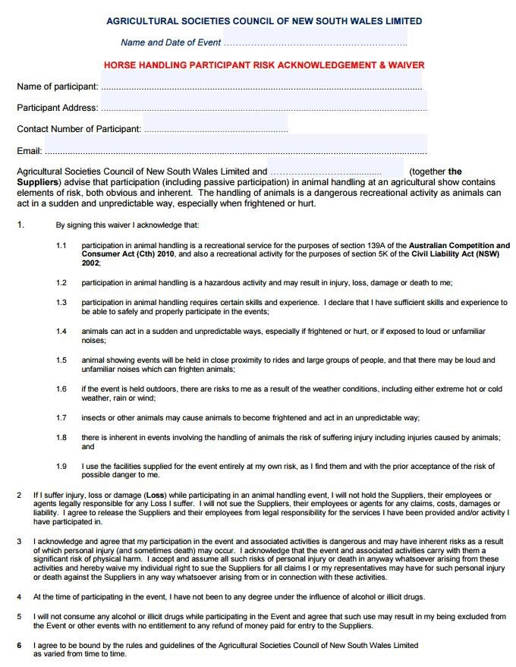

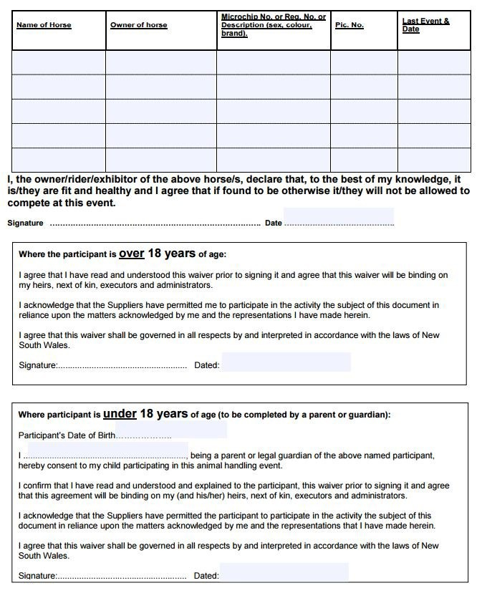

|  |  |
| --- | --- |
| **Ring 4 Breeds LED**  **Standardbred**   1. Best Presented Standardbred 2. Led Colt Under 4 3. Led Stallion over 4 4. **Champion and Reserve Standardbred Colt or Stallion** | **Australian National Saddle Horse Association (ANSA)**   1. Led 14-15h 2. Led 15-16h 3. Led over 16h 4. **Champion and Reserve Led ANSA** |
| 1. Led Mare or filly Under 4 2. Led Mare over 5 3. **Champion and Reserve Standardbred Mare or Filly** | **Australian Saddle Pony Association (ASPA)**   1. Led Mare 2. Led Gelding   **Champion and Reserve Led ASPA** |
| 1. Led Gelding 5 and Under 2. Led Gelding 6 and over 3. **Champion and Reserve Standard Bred Gelding** | **Riding Pony**   1. Led Mare 2. Led Gelding 3. **Champion and Reserve Led RPSBS** |
| **Thoroughbreds**   1. Led Mare or FILLY 2. Led Gelding   **Champion & Reserve Led** | **Purebred Welsh**   1. Led Mare 4 years and over 2. Led Gelding 4 years and over 3. Led Colt, filly or gelding 3 years and under   **Champion and Reserve Led Purebred Welsh** |
| **Arabian and Arabian Derivatives**   1. Led Mare or Filly 2. Led Gelding 3. **Champion & Reserve Led Arabian and Arabian Derivatives** | **Partbred Welsh**   1. Led Mare 2. Led Gelding 3. **Champion and Reserve Led Part Welsh**   **Warmbloods**   1. Led Warmblood Mare 2. Led Warmblood Gelding 3. **Champion and Reserve Led**   **Any other breed**   1. Led Mare 2. Led Gelding 3. **Champion and Reserve Led Any other Breed** |

|  |  |
| --- | --- |
| **Ring 4 Breeds - :RIDDEN**  **Standardbreds**   1. Beginner Ridden ( walk and trot only ) 2. Novice Ridden 3. Open Ridden 4. **Champion and Reserve Ridden Standardbred** | **Australian Saddle Pony Association (ASPA)**   1. Ridden ASPA Mare 2. Ridden ASPA Gelding 3. **Champion and Reserve Ridden ASPA** |
| **Thoroughbreds**   1. Ridden Mare 2. Ridden Gelding 3. **Champion & Reserve Ridden Thoroughbred** | **Riding Pony**   1. Ridden Riding Pony Mare or filly 2. Ridden Riding Pony Gelding 3. **Champion & Reserve Ridden Riding Pony** |
| **Arabian and Arabian Derivatives**   1. Ridden Arabian and Arabian Derivatives Mare or Filly 2. Ridden Arabian and Arabian Derivatives Gelding 3. **Champion & Reserve Ridden Arabian and Arabian Derivatives** | **Ridden Purebred Welsh**   1. Ridden Purebred Welsh Mare 2. Ridden Purebred Welsh Gelding 3. **Champion & Reserve Ridden Purebred Welsh** |
| **Australian National Saddle Horse Association (ANSA)**   1. Ridden ANSA 14-15h 2. Ridden ANSA 15-16h 3. Ridden ANSA over 16h 4. **Champion and Reserve Champion Ridden ANSA** | **Ridden Part Welsh**   1. Ridden Part Welsh Mare 2. Ridden Part Welsh Gelding 3. **Champion & Reserve Ridden Part Welsh**   **Warmbloods**   1. **Ridden Warmblood Mare** 2. **Ridden Warmblood Gelding** 3. **Champion & Reserve Ridden Warmblood**   **Any other breed**   1. Ridden Mare 2. Ridden Gelding 3. **Champion and Reserve Ridden any other Breed** |

|  |  |
| --- | --- |
| **RING 5 Australian Stockhorses** | |
| **Led ASH**  **Champion Winners in ASH Ring - prize money: $15**  **Reserve Champion Winners in ASH Ring - $10**   1. Led ASH 3 years and under (any sex) 2. Led ASH Mare 4 years and over 3. Led ASH Gelding 4 years and over 4. Led ASH Stallion 4 years and over 5. **Champion and Reserve Led ASH** | |
| **Ridden ASH**   1. ASH Hack to be ridden by a junior under 13 years 2. ASH Hack to be ridden by a juvenile 13 and under 18 years 3. ASH Hack 3 years and under (any sex) 4. ASH Maiden Hack 5. ASH Open Hack Mare 4 years and over 6. ASH Open Hack Gelding 4 years and over 7. ASH Open Hack Stallion 4 years and over 8. **Champion and Reserve ASH Hack** | **Working ASH**   1. ASH Working to be ridden by a junior under 13 years 2. ASH Working to be ridden by a juvenile 13 and under 18 years 3. ASH Working 3 years and under (any sex) 4. ASH Maiden working 5. ASH Open working Mare 4 years and over 6. ASH Open working Gelding years and over 7. ASH Open working Stallion 4 years and over 8. **Champion and Reserve ASH Working** |

|  |
| --- |
| **RING 5 Fun Classes (commencing at the conclusion of the ASH classes** |
| LED   1. Fancy dress horse/pony (rider on board ok) Best presented horse/pony 2. Horse/pony with the prettiest mane Horse/pony with the prettiest tail Best coloured horse/pony 3. Beginner’s horse/pony (have not won a first at any show) 4. Led pony under 14hh 5. Led galloway 14hh ne 15hh 6. Led hack 15hh and over 7. Led pair of ponies/horses 8. Horse/pony with the best trick Horse/pony with the longest mane Horse/pony with the longest tail 9. Cleanest horse/pony and rider combination 10. **CHAMPION LED FUNKHANA HORSE/PONY**   RIDDEN CLASSES   1. Leading rein pony under 14hh Leading rein horse 14hh and over Beginners pony under 14hh Beginners horse 14hh and over Pony under 14hh 2. Galloway over 14hh ne 15hh 3. Hack over 15hh 4. District horse/pony 5. Best walking horse/pony 6. Veteran horse/pony (over 15 years) Ridden pair of ponies/horses 7. **CHAMPION RIDDEN FUNKHANA HORSE/PONY**   RIDER CLASSES Leading rein rider Rider under 8 years   1. Rider 8 years and under 12 years Rider 12 years and under 15 years Rider 15 years and under 17 years Rider 17 years and over 2. Pair of riders under 17 years Pair of riders over 17 years 3. **CHAMPION FUNKHANA RIDER**   **Encouragement Award** |

Ring 6

|  |  |
| --- | --- |
| **Clydesdales and Heavy Horses**  **Sections 601 to 612 open only to numbered horses in or accepted for entry in**  **the Stud Book of the Commonwealth Clydesdale Horse Society** | |
| **Clydesdales**   1. STALLION, 4 years and over 2. COLT, 2 years & under 4 years 3. COLT, yearling 4. MARE, 4 years and over – Dry or Brood 5. FILLY, 2 years and under 4 years 6. FILLY, yearling 7. Gelding – 5 years and over 8. Gelding – under 5 years 9. **Champion and Reserve Stallion/ Colt** 10. **Champion and Reserve Mare/Filly** 11. **Champion and Reserve Gelding** 12. **Grand Champion Clydesdale of the Show - Les Williams Memorial Trophy**   **Trophy donated by the Williams family.**  **Led Heavy Horse any other breed**   1. Led Heavy horse mare 2. Led Heavy horse gelding 3. **Champion Led Heavy Horse any other Breed** | **Clydesdale and Heavy Horse Working Classes**   1. Single Horse in long reins – obstacle course 2. Single horse in long reins – sled obstacle course 3. Pair horses in long reins – obstacle course 4. Single horse in a 2 – wheeled vehicle 5. **Champion and Reserve Clydesdale/Heavy Horse**   **Clydesdale and Ridden Heavy Horses**   1. Ridden Heavy Horse Mare 2. Ridden Heavy Horse Gelding 3. **Champion & Reserve Ridden Heavy Horse** |
| **SUPREME LED BREED EXHIBIT OF THE SHOW**  **SUPREME RIDDEN BREED EXHIBIT OF THE SHOW**  **(TO BE JUDGED AT THE CONCLUSION OF ALL CLASSES IN RINGS 4, 5 and 6 BY THE RING 4, 5 and 6 JUDGES)** | |